# Tuesday, 27 August 2024

Meeting w/ Mona and Dr Atiyeh:

Biggest issue right now:

-EDT being higher than RT60 for some scenes, is this okay/plausible? (Curve is

-Inaccuracy might just be because subpar/bad material assignment from the pipeline and subpar/bad mesh generation as well so acceptable?

-I haven’t tested it on my scenes yet but previously, there was a problem with imbalanced rt60 on octave bands on Mona’s ST scene using default y_fit, using y_fit [-5 -35] solve it but gives lower rt60 and higher edt than rt60 now.

Sanity check:  
-Used matlab instead of python, and created a perfect impulse response to check deconvole

-created open air test scene for very low reverb/check whats wrong with unity recording on controlled environment

Mona gave new setting which is just default which what I had been using, main difference is this is unified like I suggested before to Dr Hansung and Dr Atiyeh, so 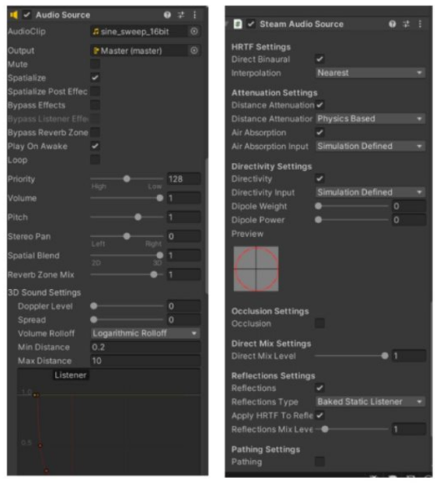

Main difference from mine is the doppler level which should not affect anyway and as tested afterward, yea not really. However, I also set the volume level to 1 now and just use attenuation on Unity Master volume mixer instead to make sure no clipping

Tested Mona’ python deconvolve vs mine (matlab) on KT scene, and both got very similar result so can confirm that mine works as well, and will continue to use mine because less move/drag/rename involved compared to Mona’s one. (mine is more streamlined imo because just rename the .wav file name so less chance for careless error etc.

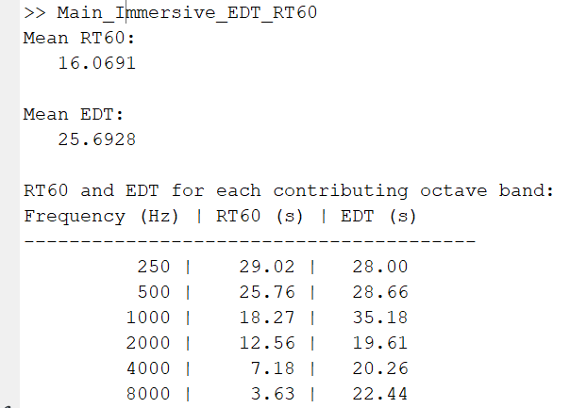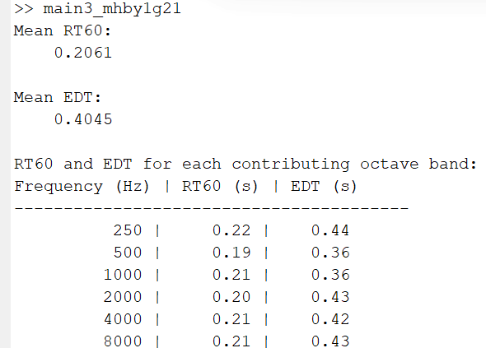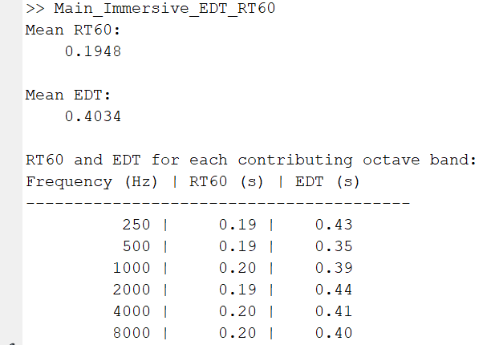Below is result (all y_fit [-5 -35] to make sure all band balanced, with first two using mona python deconvolve on 0db attenuation and two at right at -20db attenuation respectively (clipped and non clipped audio) and mine (rightmost) using only main2 and main3 matlab file, all using 10sec sweep:

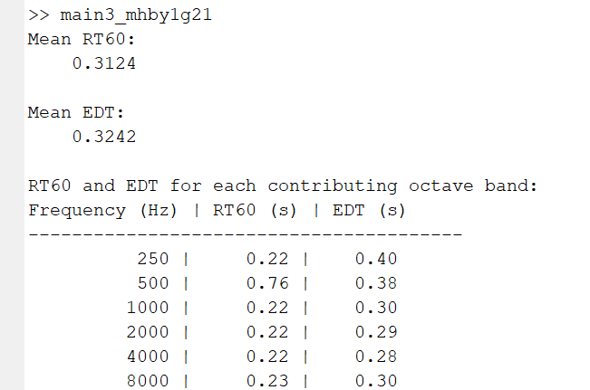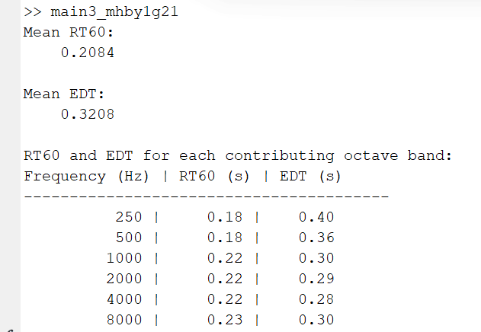MR at -15 attenuation (audio clipped a bit, maybe culprit for unbalanced band as seen at 500Hz?) and -20 attenuation, using matlab sweep and monasetting and y_fit [-5 -35]:L

For LR, for some reason, it works as expected of LR now, although this is a bit weird because the automatically assigned material is metal which should be reflective instead of absorbent.. 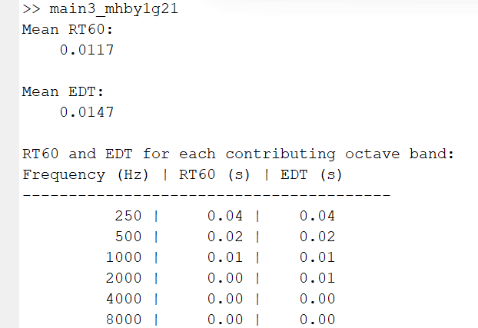

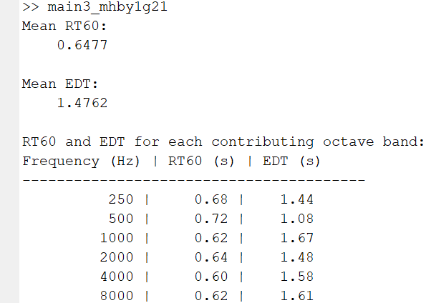ST give very low reverb still, still can hear the reverb is longer than others but still not long enough. Here is result with -10db attenuation:

I’m maxing everything on steam audio settings for baked, it gonna take longer to bake but hopefully can be more accurate lets see, called it maxbaked.

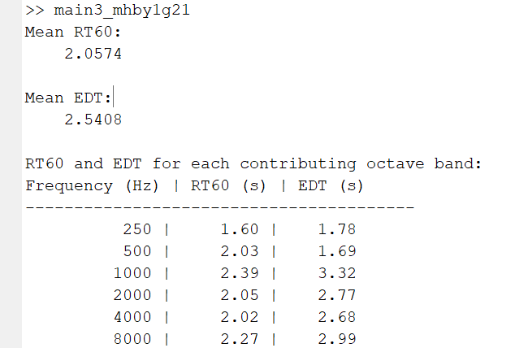0db attenuation y_fit [-5 -35] ST result:

OK, so as seen on the right, maxing the global steam audio setting all the way for baking obviously works… idk why I didn’t do it earlier or experiment with this obvious setting first instead of others… Especially when some of them are called max bounces/rays etc which would obviously refers to reverb bounce and less bounce means less reverb…

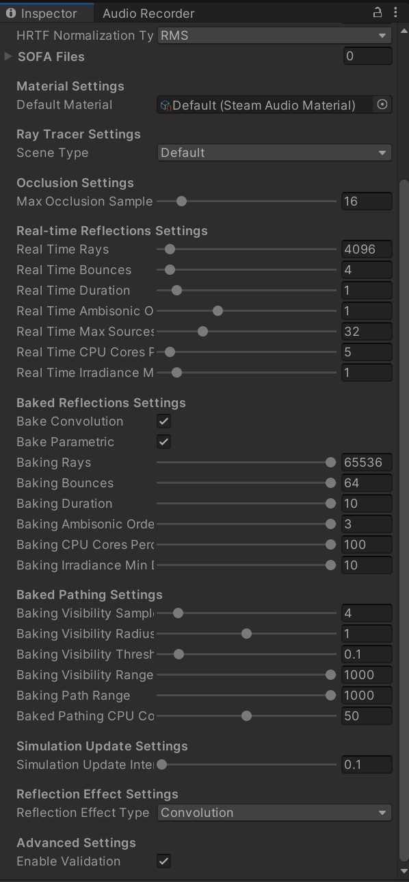For RIR measurement (EVAL scene), the perspective correction (HRTF related) option is disabled.

Now I need to redo previous 3 scene to use this max as well

Lets use heading so its easier to refer later then, ST is above.

For some reason, the volume mixer attenuation sometimes bypass all reverb and just output the sweep directly, which is what happen to LR before, so lets not use volume mixer and just change the audio source volume directly if its clipping. OK I take it back, that was not the source of the issue, its probably the steam audio itself not being engaged or something… Lets restart unity

This is most likely the culprit?

## 

OK that was not it, apparently it’s the baking irradiance min most likely, it was set too high.

## KT maxbaked result:

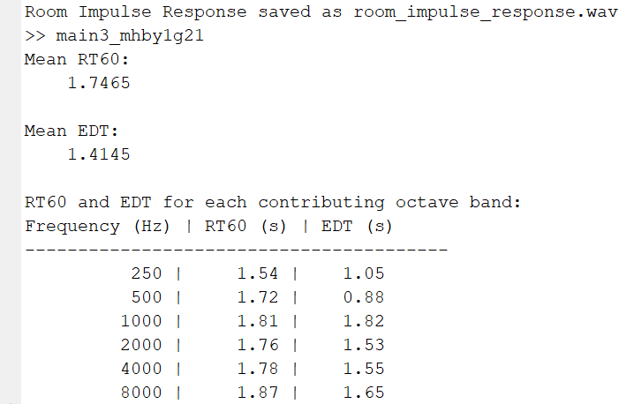Ok, this is too high now, even on y_fit [-5 -35]…

Using radeon rays is great so can utilize GPU for faster baking, however trueaudio next give errors.

Lets try half max baked setting:

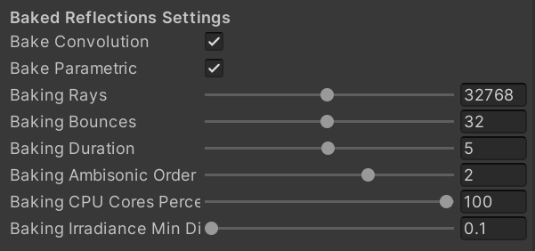

Halfmaxbaked setting is still too high, so lets try this 1/3 ish from max 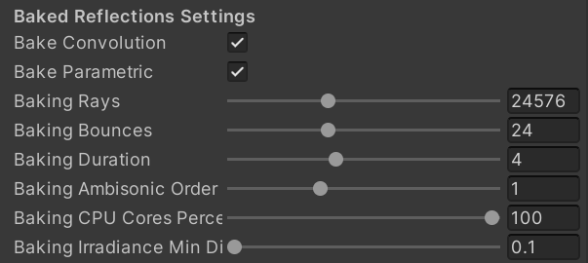

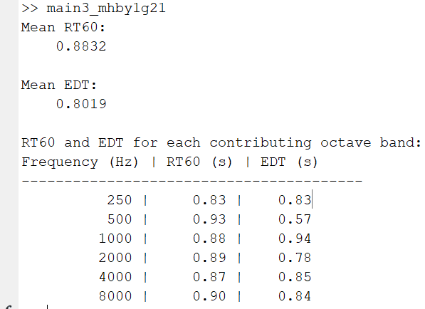Result:

Yea, still too high…

OK I gave up, this is more pain than worth at this moment as im running out of time, especially if each scene require fine tuning with different parameter..

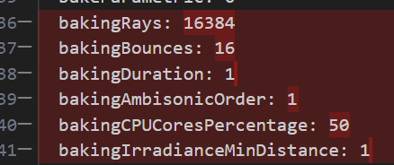Fwiw, this is the original/default parameter setting for global steam audio setting for baking  
before maxbaked etc.

Then lets just use previous result because I don’t really have time and energy to rerun them either. And lets get UL using the default first, then maybe ST using onethird or halfmax to see if its better than max. Then combine them into one neat graph/table etc.

# Wednesday, 28 August 2024

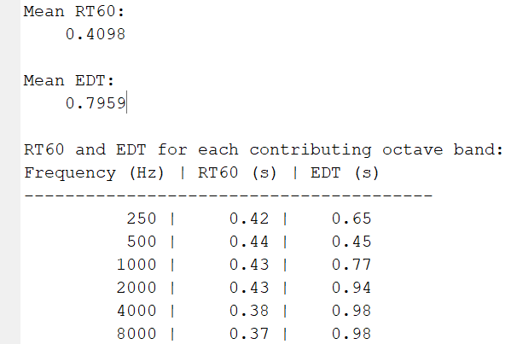NVM, UL on onethird max is too high, lets go back to default steam audio global settings.

Yep, this works perfectly.

For some reason, LR sound source being to close to wall causes steam audio to not render properly, so I moved it from z=0.51 to z=1.

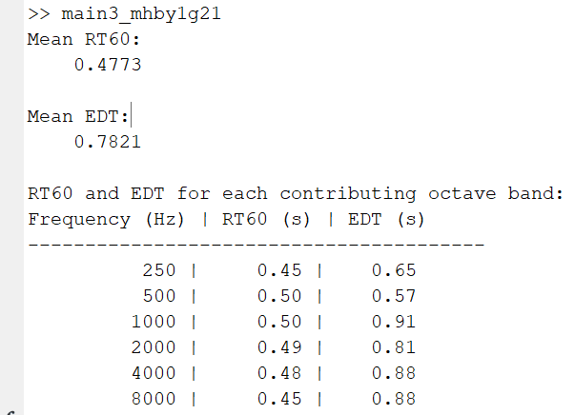LR -20db attenuation default setting:

Now we get as expected, a very wrong LR as the wall is assigned wrongly to metal instead of foam/fabric material

Now lets compile all the result into a table here or in excel so we can graph it.

The result is in InternLogs/AudioResult.xlsx

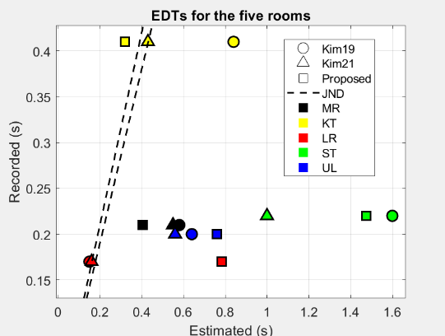Here is EDT and RT60 graph plotted against approximate Kim19 and Kim21.